Petition to Mayor Tom Mackin and Perrysburg City Council Designated Outdoor Refreshment Area (DORA) @ Levis Commons Presented by Levis Commons Partnership

Submitted on May 30, 2019
Meeting with City of Perrysburg on June 4, 2019 Revised and Submitted on June 24, 2019
Revised and Submitted on March 22, 2022

March 22, 2022

Mayor Tom Mackin, City of Perrysburg & Perrysburg City Council 201 W. Indiana Avenue
Perrysburg, OH 43551

RE: Petition for Designated Outdoor Refreshment Area (DORA) @ Levis Commons
Dear Mayor Mackin & Perrysburg City Council,
The Levis Commons Partnership is requesting to create a Designated Outdoor Refreshment Area (DORA) @ Levis Commons, which would allow patrons at participating restaurants, bars, and entertainment venues to hold no more than sixteen (16) fluid ounces of an open alcoholic beverage in a designated DORA cup only in designated area. With our request, we’re asking that the City of Perrysburg pass a new ordinance, pursuant to Ohio Revised Code 4301.82, to create a Designated Outdoor Refreshment Area (DORA) @ Levis Commons. The existing legislation requires specific considerations to which we propose in this petition.
Our sole mission is focused on advancing the Levis Common’s experience. We believe that DORA will benefit City of Perrysburg by attracting more guests and residences, increasing revenue to the businesses and lead to more sales tax, improve entertainment and charity events, allow our restaurants to be more competitive and forward thinking, and continuing the growth and reputation of Levis Commons and Perrysburg. The Levis Commons Partnership is committed to assisting with the implementation and education that goes along with the opportunity of advancing DORA.
We submit this petition to you with broad support from the restaurants, bars, merchants, retailers, hotels, residences, office workers, and owners at Levis Commons. We look forward to collaborating with City of Perrysburg in creating DORA and advancing the Levis Common’s experience. Please let us know if you have questions or if we can be of further assistance as you pursue this new ordinance.
Sincerely,

Rita Nelson, General Manager Mel Ayers, Owner

Hill Partners Nagoya & Basil Restaurants
419-931-8888 419-656-2043
RNelson@hillpartnersinc.com mel@nagoyaohio.com

Contents in Petition

- Introduction Letter to Mayor Mackin & Perrysburg City Council page 1
- Contents in Petition page 2
- Specific boundaries of the area page 3
- Parcels included in the area page 4
- Signage designating the area page 5
- Sign Design page 6
- Hours of operation and other pertinent information page 7
- Cup Design and other important rules page 8
- Participating merchants page 10
- Land use and zoning page 11
- Rules for the area page 12
- Positive economic impacts page 13
- Ohio Revised Code page 13- 16
- Signatures of Support for DORA page 17

ORC 4301.82(B)(1), 4301.82(B)(1)(b), 4301.82(D)(2) and 4301.82(F)(1)(a)
Specific boundaries of the area, including street addresses
Specific boundaries of DORA: Dixie Highway, Roachton Road, drainage ditch east of Micheal Owens Way, and N. Wilkinson Way.
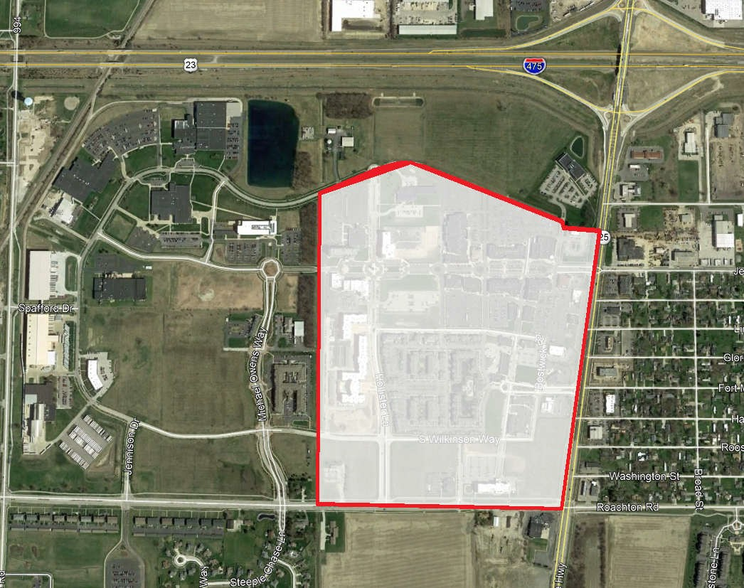
This area encompasses approximately 135 acres. A population of fifty - thousand or less is composed of three hundred twenty or fewer contiguous acres.

Parcels Included within the Boundary
ID | OWNER | ADDRESS | CITY | STATE | ZIP
Q61-400-180007004000 | MOSAIC AT LEVIS COMMONS LLC | 1000 HOLLISTER LN | Perrysburg | OH | 43551
Q61-400-180007009001 | TOLEDO EDISON COMPANY | 0 ROACHTON RD | Perrysburg | OH | 43551
Q61-400-180007009000 | MEADOWOOD ASSET MANAGEMENT LLC | 1721 S WILKINSON WY | Perrysburg | OH | 43551
Q61-400-180007019001 | PRESTON GARDENS DEVELOPMENT, LLC |  | Perrysburg | OH | 43551
Q61-400-180007019000 | PRESTON GARDENS DEVELOPMENT, LLC | 0 HOLLISTER LN | Perrysburg | OH | 43551
Q61-400-180007019002 | MIDLAND AGENCY OF NORTHWEST OHIO INC TRUSTEE | 12780 ROACHTON RD | Perrysburg | OH | 43551
Q61-400-180007018002 | LEVIS LODGING | 0 S WILKINSON WY | Perrysburg | OH | 43551
Q61-400-180007018003 | LEVIS HOSPITALITY LLC | 12710 ROACHTON RD | Perrysburg | OH | 43551
Q61-400-180007018500 | LEVIS HOSPITALITY LLC | 0 ROACHTON RD | Perrysburg | OH | 43551
Q61-400-180007013001 | PRESTON GARDENS ASSOCIATES | 5101 HOLLENBECK | Perrysburg | OH | 43551
Q61-400-180007013000 | BNR GROUP LLC | 4185 CHAPPEL DR | Perrysburg | OH | 43551
Q61-400-180007016000 | R&J CONSTRUCTION INC & DOUGLAS MANOR LTD | 2110 PRESTON PW | Perrysburg | OH | 43551
Q61-400-180007017000 | COMPASS ACQUISITIONS LLC | 5100 BROCKWAY PL | Perrysburg | OH | 43551
Q61-400-180007015000 | DIRECTIONS CREDIT UNION INC | 4150 BROCKWAY DR | Perrysburg | OH | 43551
Q61-400-180007001002 | OTTO AND DEE WEIK FAMILY LIMITED PARTNERSHIP | 4100 BROCKWAY LN | Perrysburg | OH | 43551
Q61-400-180007014001 | CHAPPEL PLACE, LLC | 0 CHAPPEL DR | Perrysburg | OH | 43551
Q61-400-180007014000 | YU LI | 4100 CHAPPEL DR | Perrysburg | OH | 43551
Q61-400-180008018001 | BROWNSTONE VILLAGE AT LEVIS COMMONS HOMEOWNERS' ASSOCIATION INC | 0 BOSTWICK RD | Perrysburg | OH | 43551
Q61-400-180008013000 | GUNZENHAEUSER KATHLEEN R | 5122 BOSTWICK RD | Perrysburg | OH | 43551
Q61-400-180008018000 | WOOD KENNETH P | 5102 BOSTWICK RD | Perrysburg | OH | 43551
Q16-400-180008017000 | STEPHEN D ISEMAN | 5106 BOSTWICK RD | Perrysburg | OH | 43551
Q61-400-180008016000 | VANHOOZEN HALLIE B TRUSTEE | 5110 BOSTWICK RD | Perrysburg | OH | 43551
Q61-400-180008015000 | 2132 BURROUGHS DRIVE LLC | 5114 BOSTWICK RD | Perrysburg | OH | 43551
Q61-400-180008014000 | BRIGADIER SEAN M & CAMON | 5118 BOSTWICK RD | Perrysburg | OH | 43551
Q61-400-180008012000 | RADABAUGH LYNN O | 5132 BOSTWICK RD | Perrysburg | OH | 43551
Q61-400-180008011000 | WAYNE GAIL & VIRGINIA E JONES | 5136 BOSTWICK RD | Perrysburg | OH | 43551
Q61-400-180008010000 | YUSTICK AMY E & ROBERT J | 5140 BOSTWICK RD | Perrysburg | OH | 43551
Q61-400-180008009000 | SCULFORT JACK T | 5144 BOSTWICK RD | Perrysburg | OH | 43551
Q61-400-180008008000 | ERNSEBERGER SALLY | 5148 BOSTWICK RD | Perrysburg | OH | 43551
Q61-400-180008007001 | ERNSEBERGER SALLY | 5148 BOSTWICK RD | Perrysburg | OH | 43551
Q61-400-180008007000 | SAVAGE CAROL A TRUSTEE | 5152 BOSTWICK RD | Perrysburg | OH | 43551
Q61-400-180008006000 | HUFFMAN JOHN L | 5162 BOSTWICK RD | Perrysburg | OH | 43551
Q61-400-180008005000 | DAVIS NICOLE J | 5166 BOSTWICK RD | Perrysburg | OH | 43551
Q61-400-180008004000 | SENATOR INTERNATIONAL PROPERTY LLC | 5170 BOSTWICK RD | Perrysburg | OH | 43551
Q61-400-180008003000 | MARTIN MARY JANE | 5174 BOSTWICK RD | Perrysburg | OH | 43551
Q61-400-180008002000 | LIEBENTHAL MICHAEL J | 5178 BOSTWICK RD | Perrysburg | OH | 43551
Q61-400-180008001000 | THERRY FABOZZI | 5182 BOSTWICK RD | Perrysburg | OH | 43551
Q61-400-180007021000 | NW ORLEANS PROPERTIES LLC | 0 HOLLISTER LN | Perrysburg | OH | 43551
Q61-400-180007021001 | NW ORLEANS PROPERTIES LLC | 3290 LEVIS COMMONS BLVD | Perrysburg | OH | 43551
Q61-400-180007006000 | OI LEVIS PARK STS INC | 0 WILKINSON WY | Perrysburg | OH | 43551
Q61-400-180007012001 | BERMAN BUILDING COMPANY INC | 0 BOSTWICK RD | Perrysburg | OH | 43551
Q61-400-180007021004 | NW ORLEANS PROPERTIES LLC | 0 HOLLISTER LN | Perrysburg | OH | 43551
Q61-400-180007010002 | LEVIS COMMONS LLC | 3201 LEVIS COMMONS BLVD | Perrysburg | OH | 43551
Q61-400-180007010004 | LEVIS COMMONS LLC | 3155 CHAPPEL DR | Perrysburg | OH | 43551
Q61-400-180007010003 | LEVIS COMMONS LLC | 0 DIXIE HWY | Perrysburg | OH | 43551
Q61-400-180007002003 | NATIONAL RETAILPROPERTIES LP | 1303 LEVIS COMMONS BLVD | Perrysburg | OH | 43551
Q61-400-180007010005 | LEVIS COMMONS LLC | 0 WILKINSON WY | Perrysburg | OH | 43551
Q61-400-180007022000 | KRE HIP GARDEN PERRYSBURG OWNER LLC | 5995 LEVIS COMMONS BLVD | Perrysburg | OH | 43551
Q61-400-180007022001 | KRE HIP GARDEN PERRYSBURG OWNER LLC | 5995 HOLLISTER LN | Perrysburg | OH | 43551
Q61-400-180007003000 | BOWLING GREEN STATE UNIVERSITY | 1655 WILKINSON WY | Perrysburg | OH | 43551
Q61-400-180007002004 | KRE HIP GARDEN PERRYSBURG OWNER LLC | 0 DIXIE HWY | Perrysburg | OH | 43551
Q61-400-180007021003 | KRE HIP GARDEN PERRYSBURG OWNER LLC |  | Perrysburg | OH | 43551

ORC 4301.82(F)(1)(b)
Number, spacing, and type of signage designating the area
Signage will include “No DORA cups beyond this point” and signs will be placed at every crosswalk and/or street leaving the designated area. Levis Commons Partnership will design a sign that will be approved by City of Perrysburg. Below is a map showing (14) proposed DORA sign locations and a sample sign. Final determination of number of signs, spacing and type will be approved by City of Perrysburg.
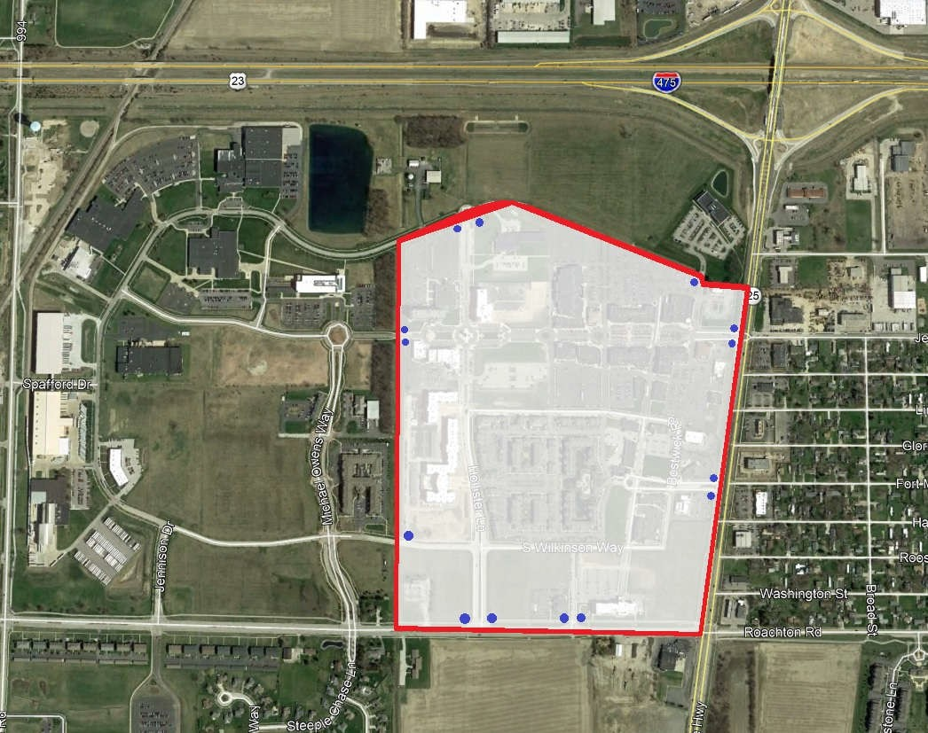

• = Sign

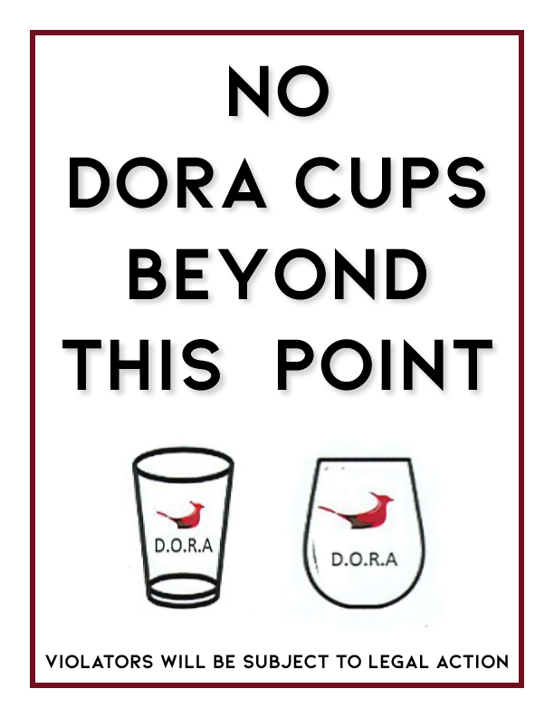
Sign Design

ORC 4301.82(F)(1)(c)
Hours of operation for area
Liquor permitted establishments may serve DORA cups 7 days a week from Noon until 11:00 p.m. (last DORA sales). All DORA beverages MUST be disposed of by 12:00 a.m.

ORC 4301.82(B)(5) and ORC 4301.82(F)(1)(d)
Number of personnel needed to ensure public safety in the area and communication with police.
Levis Commons Partnership will work with the on-site privately contracted security company to ensure understanding, training and compliance of all DORA rules and regulations for standard day to day activity and operations. Current security staffing is 217 hours per week with personnel patrolling the grounds until midnight on weekends. There is also 25+ security cameras throughout the site. Each participant will also be educated and trained to assist with public safety.
In addition to daily operations, Levis Commons Partnership will communicate directly with Perrysburg Police on all special events that would impact or increase the DORA usage. Any event expected to attract in excess of 200 people, or any event directly related to DORA consumption such as wine tastings, street fairs, craft beer sampling etc. will be considered notable and be preceded with a form submission to the police department at least 30 days prior to the event. The form submission will include the date and time of the event, an overview of the event, the planned security staffing for the event, the expected attendance of the event and the contact information for the event coordinator. If requested with due reasoning, Levis Commons Partnership will hire off duty officers per Perrysburg Police specifications to help manage the event.

ORC 4301.82(B)(5), ORC 4301.82(F)(1)(e) and ORC 4301.82(F)(1)(f)
Sanitation plan that will help maintain the appearance and public health of the area and number of personnel needed to execute the sanitation plan
Trash receptacles:

Trash receptacles will be provided outside each permitted establishment participating in the sale of alcohol in open containers and at each block corner within the area. Trash receptacles will be serviced as necessary to maintain a clean environment.
General litter and debris:

Maintaining a clean environment within the designated area and all Levis Commons is paramount and will include daily pickup of litter and debris. As with servicing the trash receptacles, this maintenance is currently contacted out to a couple companies with several personnel that maintain Levis Commons.

Cup Design
FRONT:
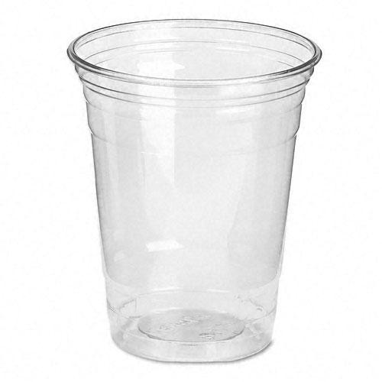

D.O.R.A
D.O.R.A

BACK:
THREE SIMPLE RULES:

DORA cups are allowed:
Seven days a week
Noon - 11pm

DORA cups are not allowed beyond the boundary signs

Dora cups are only permitted in Levis retailers with DORA logo on their door
THREE SIMPLE RULES:

DORA cups are allowed:
Seven days a week
Noon - 11pm

DORA cups are not allowed beyond the boundary signs

Dora cups are only permitted in Levis retailers with DORA logo on their door
ORC 4301.82(F)(1)(g)
All beer, wine, and intoxicating liquor will be served and contained in the official DORA plastic bottles or other non-glass container with the logo. No other containers are permitted.
Levis Common Partnership will design a unique and easily identifiable official cup for DORA @ Levis Commons. The official cup will be able to hold no more than sixteen (16) fluid ounces and will be composed of plastic. See proposed logo in addendum.

ORC 4301.82(B)(2)
Nature and types of establishments that will be located within the proposed refreshment area:
Levis Commons is a lifestyle center that is a highly sought-after place to live, work, shop, dine, and entertain. There is a diverse combination of retail, restaurants, bars, offices, apartments, hotels, single family residences (brownstones), and professional service businesses.

ORC 4301.82(B)(3)
Qualifying establishments participating in DORA.
DORA will encompass not fewer than four qualified permit holders. Levis Commons Partnership has identified (14) qualified permit holders that will be included in DORA; with the understanding there is a potential of more participants in 2022.

ORC 4301.82(B)(4)
Evidence that the uses of land within the proposed outdoor refreshment area are in accord with the master zoning plan:
Zoning in the designated DORA area is Urban Village Special Overlay
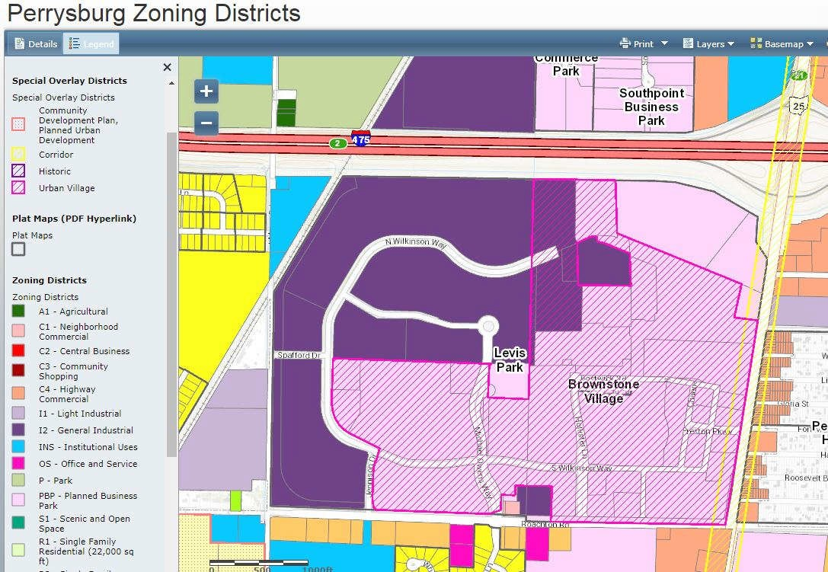

ORC 4301.62(C)(7)
Rules of The Area
Rules of Ohio Substitute House Bill 47:
ORC 4301.62(C)(7)(a):
A person may have in the person’s possession an opened container of beer or intoxicating liquor at an outdoor location within an outdoor refreshment area created under 4301.82 of the Ohio Revised Code if the opened container of beer or intoxicating liquor was purchased from a qualified permit holder to which both of the following apply:
- The permit holder’s premise is located within the outdoor refreshment area.
- The permit is held by the permit holder has an outdoor refreshment area designation.
ORC 4301.62(C)(7)(b):
Outdoor Refreshment Area Participants may NOT:
- Enter the premises of an establishment within an outdoor refreshment area while possessing an opened container of beer or intoxicating liquor acquired elsewhere;
- Possess an opened container of beer or intoxicating liquor while being in or on a motor vehicle.
ORC 4301.82(F)(1)(g)
All beer, wine, and intoxicating liquor be served solely in plastic bottles or other non-glass containers. No other containers are permitted.
Additional Rules of DORA @ Levis Commons
Only one (1) official DORA cup will be permitted at a time per DORA patron. All DORA beverages must be served in a new and unused official cup.

Assumption of Good Behavior by DORA Patrons:
A DORA patron can expect to enjoy the Outdoor Refreshment area without restraint, questioning, or harassment SO LONG AS the DORA participant correctly follows the Rules of The Area, and maintain a decorum of good behavior, free of public drunkenness, property destruction, or any action that disrupts the enjoyment of another DORA participant, or disrupts any establishment, property owner, resident, or patron within the DORA.
Violation of any of these Rules of The Area shall be considered a minor misdemeanor and violators face warnings in accordance with ORC.

POSITIVE ECONOMIC IMPACTS
The Levis Commons Partnership is confident that the Designated Outdoor Refreshment Area will enhance the entertainment and cultural appeal of Levis Commons as a destination and will serve to enhance economic appeal and make Levis Commons and Perrysburg more attractive to businesses and residences. DORA at Levis Commons will benefit City of Perrysburg by attracting more guests and residences, increasing revenue to the businesses and lead to more sales tax, improve entertainment and charity events, allow our restaurants to be more competitive and forward thinking, and continuing the growth and reputation of Levis Commons and Perrysburg.

OHIO REVISED CODE (copy)
4301.82 Designated outdoor refreshment areas.

- As used in this section:

  - "Qualified permit holder" means the holder of an A-1, A-1-A, A-1c, A-2, A-2f, or D class permit issued under Chapter 4303. of the Revised Code.

  - "D class permit" does not include a D-6 or D-8 permit.

- The executive officer of a municipal corporation or the fiscal officer of a township may file an application with the legislative authority of the municipal corporation or township to have property within the municipal corporation or township designated as an outdoor refreshment area or to expand an existing outdoor refreshment area to include additional property within the municipal corporation or township. The executive officer or fiscal officer shall ensure that the application contains all the following:

  - A map or survey of the proposed outdoor refreshment area in sufficient detail to identify the boundaries of the area, which shall not exceed either of the following, as applicable:

    - Six-hundred forty contiguous acres if the municipal corporation or township has a population of more than fifty thousand as specified in division (D) of this section;

    - Three hundred twenty contiguous acres if the municipal corporation or township has a population of fifty thousand or less as specified in division (D) of this section.

  - A general statement of the nature and types of establishments that will be located within the proposed outdoor refreshment area;

  - A statement that the proposed outdoor refreshment area complies with division (D) of this section;

  - Evidence that the uses of land within the proposed outdoor refreshment area are in accord with the master zoning plan or map of the municipal corporation or township;

  - Proposed requirements for the purpose of ensuring public health and safety within the proposed outdoor refreshment area.

- Within forty-five days after the date the application is filed with the legislative authority of a municipal corporation or township, the legislative authority shall publish public notice of the application once a week for two consecutive weeks in one newspaper of general circulation in the municipal corporation or township or as provided in section 7.16 of the Revised Code. The legislative authority shall ensure that the notice states that the application is on file in the office of the clerk of the municipal corporation or township and is available for inspection by the public during regular business hours. The legislative authority also shall indicate in the notice the date and time of any public hearing to be held regarding the application by the legislative authority.

Not earlier than thirty but not later than sixty days after the initial publication of notice, the legislative authority shall approve or disapprove the application by either ordinance or resolution, as applicable. Approval of an application requires an affirmative vote of a majority of the legislative authority. Upon approval of the application by the legislative authority, the territory described in the application constitutes an outdoor refreshment area. The legislative authority shall provide to the division of liquor control and the investigative unit of the department of public safety notice of the approval of the application and a description of the area specified in the application. If the legislative authority disapproves the application, the executive officer of a municipal corporation or fiscal officer of a township may make changes in the application to secure its approval by the legislative authority.

- The creation of outdoor refreshment areas is limited as follows:

  - A municipal corporation or township with a population of more than fifty thousand shall not create more than six outdoor refreshment areas. Any such outdoor refreshment area shall include at least four qualified permit holders.

  - A municipal corporation or township with a population of fifty thousand or less shall not create more than three outdoor refreshment areas. Any such outdoor refreshment area shall include at least two qualified permit holders.

For purposes of this section, the population of a municipal corporation or township is deemed to be the population shown by the most recent regular federal decennial census.

- As soon as possible after receiving notice that an outdoor refreshment area has been approved, the division of liquor control, for purposes of section 4301.62 of the Revised Code, shall issue an outdoor refreshment area designation to each qualified permit holder located within the refreshment area that is in compliance with all applicable requirements under Chapters 4301. and 4303. of the Revised Code. The division shall not charge any fee for the issuance of the designation. Any permit holder that receives such a designation shall comply with all laws, rules, and regulations that govern its license type, and the applicable public health and safety requirements established for the area under division (F) of this section.

(F)(1) At the time of the creation of an outdoor refreshment area, the legislative authority of a municipal corporation or township in which such an area is located shall adopt an ordinance or resolution, as applicable, that establishes requirements the legislative authority determines necessary to ensure public health and safety within the area. The legislative authority shall include in the ordinance or resolution all the following:

    - The specific boundaries of the area, including street addresses;

    - The number, spacing, and type of signage designating the area;

    - The hours of operation for the area;

    - The number of personnel needed to ensure public safety in the area;

    - A sanitation plan that will help maintain the appearance and public health of the area;

    - The number of personnel needed to execute the sanitation plan;

    - A requirement that beer and intoxicating liquor be served solely in plastic bottles or other non-glass containers in the area.

The legislative authority may, but is not required to, include in the ordinance or resolution any public health and safety requirements proposed in an application under division (B) of this section to designate or expand the outdoor refreshment area. The legislative authority may subsequently modify the public health and safety requirements as determined necessary by the legislative authority.

  - Prior to adopting an ordinance or resolution under this division, the legislative authority shall give notice of its proposed action by publication once a week for two consecutive weeks in one newspaper of general circulation in the municipal corporation or township or as provided in section 7.16 of the Revised Code.

  - The legislative authority shall provide to the division of liquor control and the investigative unit of the department of public safety notice of the public health and safety requirements established or modified under this division.

(G) If an outdoor refreshment area has been created in accordance with this section, the holder of an F class permit that sponsors an event located in the outdoor refreshment area may apply to the division for issuance of an outdoor refreshment area designation. The division shall issue such a designation if the division determines that the permit holder is in compliance with all applicable requirements established under this chapter and Chapter 4303. of the Revised Code. An F class permit holder that receives a designation under this division shall do both of the following:

(1) Comply with all laws, rules, and regulations that govern its type of permit, and the applicable public health and safety requirements established for the outdoor refreshment area under division (F) of this section;

(2) Not block ingress or egress to the outdoor refreshment area or any other liquor permit premises located within the area.

(H) Section 4399.18 of the Revised Code applies to a liquor permit holder located within an outdoor refreshment area in the same manner as if the liquor permit holder were not located in an outdoor refreshment area.

(I)(1) Five years after the date of creation of an outdoor refreshment area, the legislative authority of the municipal corporation or township that created the area under this section shall review the operation of the area and shall, by ordinance or resolution, either approve the continued operation of the area or dissolve the area. Prior to adopting the ordinance or resolution, the legislative authority shall give notice of its proposed action by publication in one newspaper of general circulation in the municipal corporation or township or as provided in section 7.16 of the Revised Code.

If the legislative authority dissolves the outdoor refreshment area, the outdoor refreshment area ceases to exist. The legislative authority then shall provide notice of its action to the division of liquor control and the investigative unit of the department of public safety. Upon receipt of the notice, the division shall revoke all outdoor refreshment area designations issued to qualified permit holders within the dissolved area. If the legislative authority approves the continued operation of the outdoor refreshment area, the area continues in operation.

(2) Five years after the approval of the continued operation of an outdoor refreshment area under division (I)(1) of this section, the legislative authority shall conduct a review in the same manner as provided in division (I)(1) of this section. The legislative authority also shall conduct such a review five years after any subsequent approval of continued operation under division (I)(2) of this section.

(J) At any time, the legislative authority of a municipal corporation or township in which an outdoor refreshment area is located may, by ordinance or resolution, dissolve all or a part of the outdoor refreshment area. Prior to adopting the resolution or ordinance, the legislative authority shall give notice of its proposed action by publication one newspaper of general circulation in the municipal corporation or township or as provided in section 7.16 of the Revised Code. If the legislative authority dissolves all or part of an outdoor refreshment area, the area designated in the ordinance or resolution no longer constitutes an outdoor refreshment area. The legislative authority shall provide notice of its actions to the division of liquor control and the investigative unit of the department of public safety. Upon receipt of the notice, the division shall revoke all outdoor refreshment area designations issued to qualified permit holders or the holder of an F class permit within the dissolved area or portion of the area.

Amended by 132nd General Assembly File No. TBD, HB 522, §1, eff. 3/22/2019. Amended by 131st General Assembly File No. TBD, HB 342, §1, eff. 9/28/2016. Added by 131st General Assembly File No. TBD, HB 47, §1, eff. 4/30/2015.

